**Nicholas Shari - CSE422 - Homework #1**

Chapter1 Problems: P4; P6; P10; P12; P13; P20; P31.

P4. Consider the circuit-switched network in Figure 1.13 . Recall that there are 4 circuits on each link. Label the four switches A, B, C, and D, going in the clockwise direction.

* a. What is the maximum number of simultaneous connections that can be in progress at any one time in this network?

16

* b. Suppose that all connections are between switches A and C. What is the maximum number of simultaneous connections that can be in progress?

8

* c. Suppose we want to make four connections between switches A and C, and another four connections between switches B and D. Can we route these calls through the four links to accommodate all eight connections?

Yes. 2 connections run from A to C through B and 2 more run through D. Leaving 2 connections available or B to D through A and 2 through C.

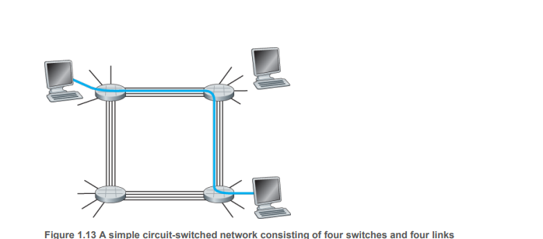

A - - - - B

| |

D- - - - -C

P6. This elementary problem begins to explore propagation delay and transmission delay, two

central concepts in data networking. Consider two hosts, A and B, connected by a single link of

rate R bps. Suppose that the two hosts are separated by m meters, and suppose the propagation speed along the link is s meters/sec. Host A is to send a packet of size L bits to Host B.

* a. Express the propagation delay, dprop , in terms of m and s.

dprop = m/s

* b. Determine the transmission time of the packet, dtrans , in terms of L and R.

dtrans = L/R

* c. Ignoring processing and queuing delays, obtain an expression for the end-to-end delay.

dend-to-end = dprop + dtrans = m/s + L/R

* d. Suppose Host A begins to transmit the packet at time t=0. At time t = dtrans, where is the last bit of the packet?
  + In the link. All bits should have left the host.
* e. Suppose dprop is greater than dtrans . At time t = dtrans , where is the first bit of the packet?
  + If the propagation is longer than transmission, the first bit of the package should be on the network but not yet arrived at the destination.
* f. Suppose dprop is less than dtrans . At time t = dtrans, where is the first bit of the packet?
  + If the transmission delay is greater than the propagation delay, the first packet has already arrived at the destination.
* g. Suppose s = 2.5x108, L=120bits , and R=56kbps. Find the distance m so that dprop equals dtrans .

dprop = dtrans = m/s = L/R = m = Ls/R

= 2.5x108 * 120bits / 56kbps

2.5x108 * 120bits / 56,000bps = 535,714.285

P10. Consider a packet of length L that begins at end system A and travels over three links to a destination end system. These three links are connected by two packet switches. Let d, s , and R denote the length, propagation speed, and the transmission rate of link i, for i=1,2,3. The packet switch delays each packet by dprop . Assuming no queuing delays, in terms of d*i*, si , Ri,(i=1,2,3) , and L, what is the total end-to-end delay for the packet? Suppose now the packet is 1,500 bytes, the propagation speed on all three links is 2.8x108m/sthe transmission rates of all three links are 2 Mbps, the packet switch processing delay is 3 msec, the length of the first link is 5,000 km, the length of the second link is 4,000 km, and the length of the last link is 1,000 km. For these values, what is the end-to-end delay?

dend-to-end = dtrans + dprop  = d/s + L/R

Link 1: 5000km/2.8x108m/s + 1500bytes/2Mbps =

0.01785714285s + 0.006s = 0.0238571s

+3msec

Link 2: 4000km/2.8x108m/s + 1500bytes/2Mbps

0.01428571428s + 0.006s = .0202857s

+3msec

Link 3: 1000km/2.8x108m/s + 1500bytes/2Mbps

0.00357142857s + 0.006s = .009571s

= 59.76ms

P12. A packet switch receives a packet and determines the outbound link to which the packet should be forwarded. When the packet arrives, one other packet is halfway done being transmitted on this outbound link and four other packets are waiting to be transmitted. Packets are transmitted in order of arrival. Suppose all packets are 1,500 bytes and the link rate is 2 Mbps. What is the queuingdelay for the packet? More generally, what is the queuing delay when all packets have length L, the transmission rate is R, x bits of the currently-being-transmitted packet have been transmitted, and n packets are already in the queue?

1 halfway, 750bytes in (x)

4 packets waiting

Packet size(L) = 1500 bytes

R = 2Mbps

dqueue = L/R

Dqueue-half = L-x / R = 750bytes/2Mbps

Dqueue-four = 4*L/R = 6000bytes/2Mbps

Dtotal = Dqueue-half + Dqueue-four = 6750bytes/2Mbps = .027seconds = 27ms

P13.

* a. Suppose N packets arrive simultaneously to a link at which no packets are currently being transmitted or queued. Each packet is of length L and the link has transmission rate R. What is the average queuing delay for the N packets?
* First packet has no delay in empty queue.
* 2nd packet is L/R
* 3rd packet is 2L/R
* Nth packet delay is (N-1) * L / R
* Average of a group of numbers

L(n-1)*n

2R

* Average of this set:
* L(n-1)*n

2R*n

L(n-1)

2R

* b. Now suppose that N such packets arrive to the link every LN/R seconds. What is the average queuing delay of a packet?

If every batch arrives at LN/R the queue would be empty as the new batch comes in.

The average delay would be

L(n-1)

2R

P20. Consider the throughput example corresponding to Figure 1.20(b) . Now suppose that there are M client-server pairs rather than 10. Denote Rs , Rc , and R for the rates of the server links, client links, and network link. Assume all other links have abundant capacity and that there is no other traffic in the network besides the traffic generated by the M client-server pairs. Derive a general expression for throughput in terms of RS , Rc , R, and M.

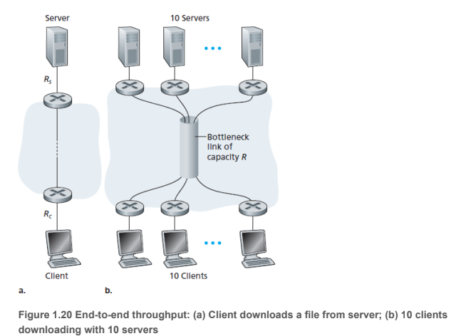

Bottleneck occurs because Rs,Rc or R/M is the smallest.

If Rs < Rc < R/M: Through = RS

min{Rs,Rc,R/M}

P31. In modern packet-switched networks, including the Internet, the source host segments long, application-layer messages (for example, an image or a music file) into smaller packets and sends the packets into the network. The receiver then reassembles the packets back into the original message. We refer to this process as message segmentation. Figure 1.27 illustrates the end-to-end transport of a message with and without message segmentation. Consider a message that is 8x106 bits long that is to be sent from source to destination in Figure 1.27 . Suppose each link in the figure is 2 Mbps. Ignore propagation, queuing, and processing delays.

* a. Consider sending the message from source to destination without message segmentation. How long does it take to move the message from the source host to the first packet switch? Keeping in mind that each switch uses store-and-forward packet switching, what is the total time to move the message from source host to destination host?

dtrans-1st-link = L/R = 8x106 bits / 2Mbps = 4 seconds

* b. Now suppose that the message is segmented into 800 packets, with each packet being 10,000 bits long. How long does it take to move the first packet from source host to the first switch? When the first packet is being sent from the first switch to the second switch, the second packet is being sent from the source host to the first switch. At what time will the second packet be fully received at the first switch?

dtrans-1st-link = L/R = 10,000 bits / 2Mbps = 0.005 seconds = 5ms

Without dprop,dqueue,dproc :

The 2nd packet will reach the 1st link in 5ms more. Total: 10ms

* c. How long does it take to move the file from source host to destination host when message segmentation is used? Compare this result with your answer in part (a) and comment.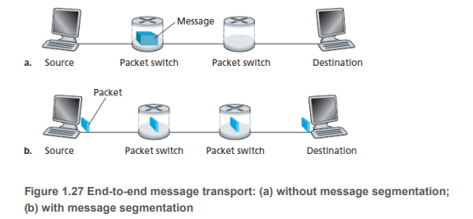

Without Segmentation:

* 3 Link : 4seconds *3 = 12 seconds.

With Segmentation(Without dprop,dqueue,dproc):

* 5ms * 800 = 4 seconds
* The last packet will add an extra 10ms to traverse the links after the first packet is finished.
* 4.01 seconds
* d. In addition to reducing delay, what are reasons to use message segmentation?

Increased security. If someone is trying to steal information they’d have to obtain and arrange every message instead of a single message.

* e. Discuss the drawbacks of message segmentation.

A single corrupt or bit error would ruin the entire message and cause it to be resent.

Depending on the timing when a small packet is received at the queue. It could be stuck behind a large packet from another source. Which results in an unfair and uneven delay.